**The Towers of Lumeth**

*Control the Chaos, or be Consumed by it*

Bioelectric Studios™



***AJ Chapman, Jacob Kemp-Scheider, Nuha Syed, Sam Deane, Will Bertiz***

**Basic Questions**

* Who is the player? (Objects)
  + Player is an apprentice of a specific school of magic. Their goal is to achieve the title of Master. The player does this by conquering the most rooms using the magical items that they find throughout their journey. Each character will have come from a different kingdom in the Small Kingdoms.
* What can they do? (Behaviors)
  + Can use spells in tower rooms alongside other players
    - Depending on what other players play, players can gain rewards that help them win the game.
* How do they do it? (Mechanics)
  + Players play cards with different numerical values in tower rooms
    - Other players also play cards, depending on what players play and if they succeeds/fails, different players gain varying rewards
  + Lead player can choose which room group goes to
* Why are they doing any of it? (Narrative context)
  + Players are apprentices in their respective school of magic, coming from different areas around the small kingdoms. They have been tasked with acquiring items from the towers of Lumeth by their respective masters. These items have been guarded for years by Morkai of the Crooked Hill, a former Wizard’s guild member who was exiled. These items have been known to be some of the most powerful items in the Small Kingdoms. The apprentice who conquers the most rooms using the magic items they find, wins the competition.

**Win Condition**

* The player who has won the most rooms at the end of the rounds
  + In case of a tie on amount of rooms won, the player with the most cards wins
    - In case of a tie on the items/cards a player has, the players add the absolute value of the cards in their hands
      * In case of a tie on the absolute values of the cards, the players both win

**Obstacles to winning**

* Other players playing against you
* Tower rooms’ clear conditions
  + Players need to play certain cards in order to complete a room

**Mechanics**

* Challenging
  + Team plays as a whole, but implicitly two different teams with positive and negative teams
    - Item cards are played facedown into a “pot” without revealing cards
    - Event cards have conditions such as “have a total higher than 4” or “have a total lower than -4” which can benefit either the positive or negative players.
    - Players can play more than one card each turn
    - Players win a round if
      * They play a positive card and the room is a success
      * They play a negative card and the room is a failure
* Tower exploration
  + Deck of tower room cards
  + New party leader is chosen after every round
    - Goes in a circle clockwise
  + Party leader draws 3 cards, plays one of those rooms to enter, then discards the other cards
* Set number of rounds
  + Number of players x 2
* Collect items to gain points
  + Items have different point values and abilities
  + Item cards have positive and negative values
  + Some items can be used to cast abilities
  + Items are consumed when their ability is used

**Basic Rules**

The players search through a tower to find magic items, trying to complete the most rooms. The game is played in a series of rounds, with one player being the party leader each round. The number of rounds is the number of players times two. Each round consists of each player having a turn as party leader. The player who last did something magical is the first party leader, party leadership moves clockwise. Players start the game by drawing 4 item cards each. Each round consists of each player having their turn at being the party leader. Each turn has 5 phases, which in order are, the draw phase, exploration phase, challenge phase, ability phase, and end phase.

The tower is full of rooms populated with different item cards. Each item card has a value between -6 and 6 and is used to try and challenge a room. Each room has a victory condition of having a total point score used of greater than -7 to 7.

The game revolves around trying to acquire room victories for yourself while also hindering others progress towards the same goal. Players do this by using the magical items that they find in their journey. Each item card has a number on it which is its point value. This value is used when playing towards trying to complete a room. There are also cursed item cards, cards with negative point values, which can be used to try and hinder other players.

The player with the most rooms completed at the end of the game wins. If multiple players have the same number of victory points, the player with the most item cards between those players wins.

**List of Tiebreakers:**

* Most victory points
* Most item cards
* Hughes absolute value of item card points

**Exploration Phase:**

* The group leader draws three room cards from the room deck
* Without showing the room cards the group leader decides which of the three cards the party will enter
  + The other two are placed in a discard pile

**Challenge Phase:**

* The players each play item cards from their hand face down
  + Players can place more than one item card
  + Players can only play all positive, or all negative cards

**Ability Phase:**

* Players can use item card abilities
  + Item cards are discarded after use

**End Phase:**

* Players flip over the cards that they played and figure out if the room was completed
* If all the players bet the same (positive or negative), no one gains anything
* Players draw item cards based on how the party did
  + Draw cards from the item deck equal to the number of players that won the round
    - The player that played the most points on the side that won the room picks which card they want
    - Next player who played most picks next etc.
* Players gain a Victory Token if they bet towards the side that won the room
* Rotate party leadership clockwise

**Mood Board**

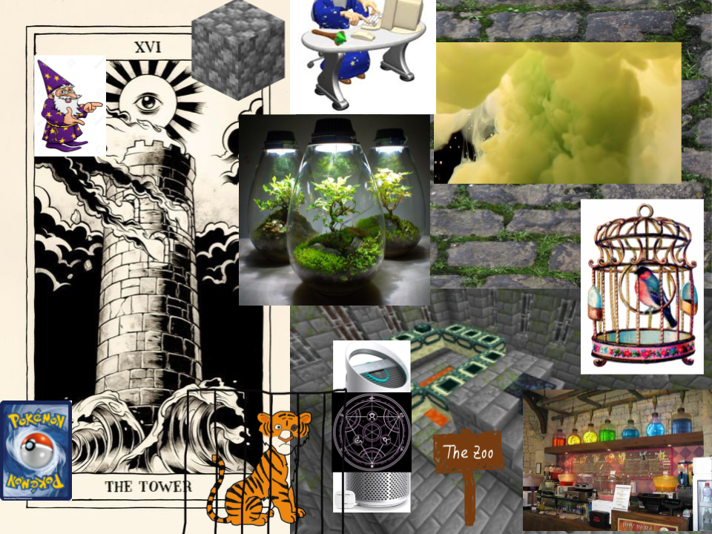

**Card Designs**

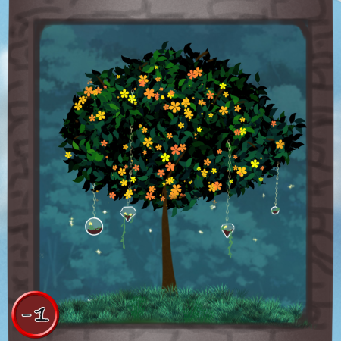

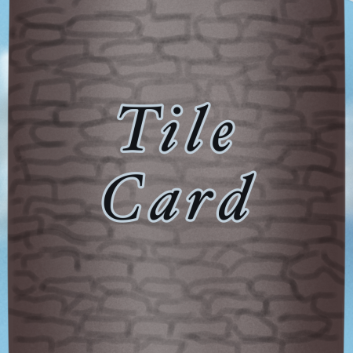

**Lore**

* Towers of Lumeth: Towers in the Small Kingdoms which are protected by high-order wizardry. The towers create breathable air for the world, allowing life to flourish. The towers are inhabited by Morkai of the Crooked Hill, an exiled wizard who possesses many magical items which the apprentices are tasked with obtaining.
  + https://ethshar.fandom.com/wiki/Towers_of_Lumeth
* Wizard in tower: Holding a multitude of magical items he was told to protect before his exile from the wizardry guild. His task is to protect careless mages from wandering into the Towers of Lumeth. When the group of apprentices approach the southern tower Morkai assumes his position to protect the tower.
  + Reference: https://ethshar.fandom.com/wiki/Morkai_of_the_Crooked_Hill
* An adventurous group of apprentices are in search of completing their training. Their final quest is to retrieve a set of magical items from the Towers of Lumeth. However, the venture will not be easy for the apprentices, they will have to venture through an assortment of obstacles thrown at them by the mighty wizard, Morkai of the Crooked Hill, guarding the tower. There’s one final twist to the apprentice’ venture, there are only enough magical items for one mage to achieve the title of Master.